Sec Gates

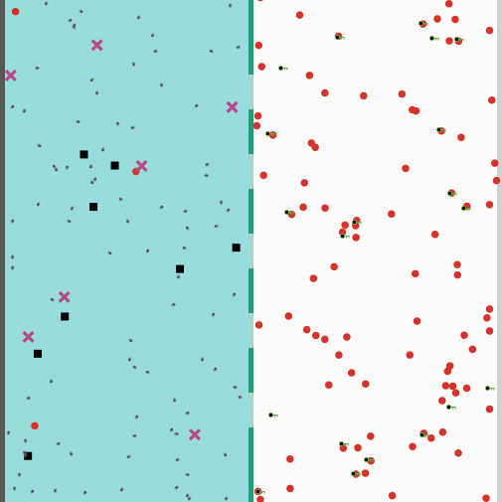

Microcystin

Inner Membrane

Periplasm

Cytoplasm



PP1-Microcystin Complexes



PP1



Degradation Proteins



SecB





Membrane Pores

TatB-C complex

Degradation Proteins

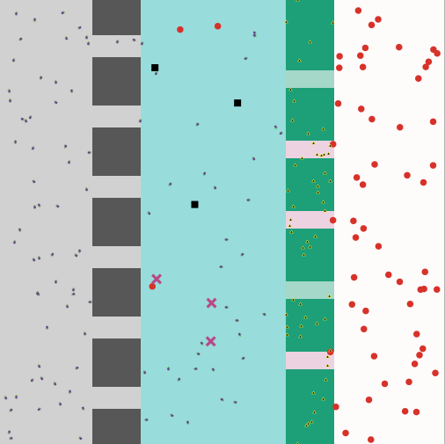



PP1



PP1-Microcystin Complexes



Outer Membrane

Inner Membrane

Microcystin

tatA

Periplasm

Cytoplasm

Extracellular Medium